**Final Project**

* **Due** No Due Date
* **Points** 300
* **Submitting** a website url

Create a learning website using the MVC template rather than Empty template.

Requirements:

1. Have a proper user interface
2. Be able to register a new user
3. Be able to log in as an existing user
4. Be able to display the list of available classes
5. Be able to register a user for a given class (after registering for a class, display the classes registered)
6. Be able to see the classes registered for the current logged in user

Create a SQL database named mini-cstructor. Create a new query and run the sql script to create the database.

Use the following script to create the tables and load the data: [mini-cstructorDb.sqlPreview the documentView in a new window](https://canvas.uw.edu/courses/1105401/files/40610115/download?wrap=1)

Use IIS Express

#1 http://localhost:12345/home/index

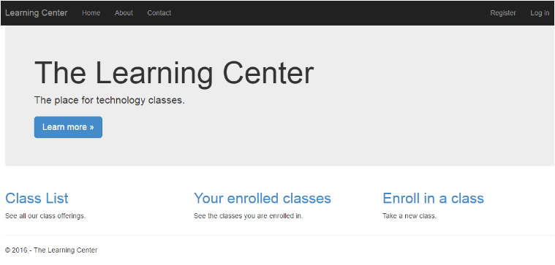

#2 <http://localhost:12345/home/register>

 When you click on the Register link, your site should have proper validation for email and password and create a user in the database.

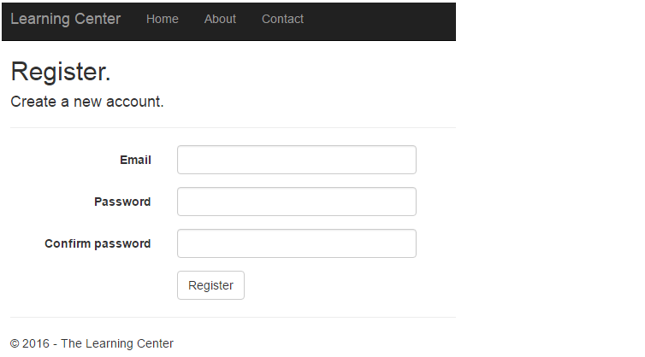

#3 http://localhost:12345/home/login

You should be able to login as an existing user.

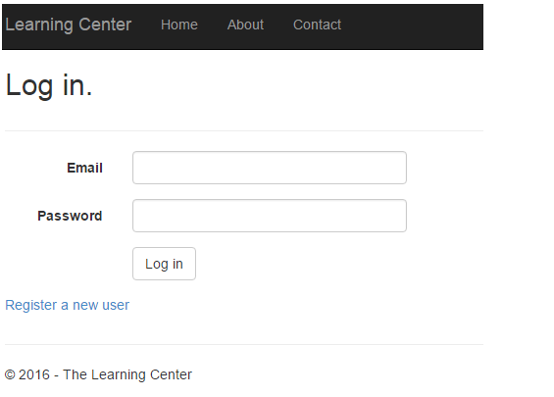

#4 http:/localhost:12345/home/classlist

Display the list of classes

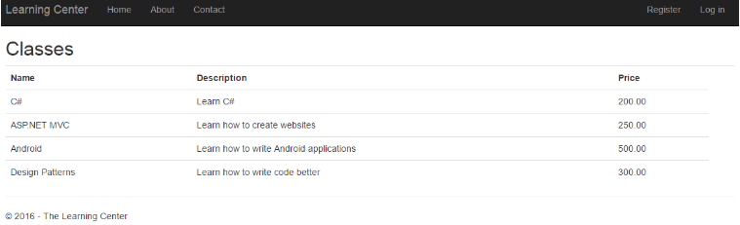

#5 http://localhost:12345/home/enrollinclass

Notice that Mike is logged in. After clicking on Add Class, go to #6.

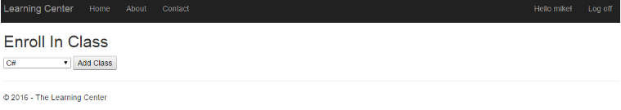

#6 <http://localhost:12345/home/studentclasses>

